**ACM-ASC Internship 2024**

**Milestone II : Phase II**

____________________________________________________________________________________________________

**TAG 3 : AI and Disabilities Studies  
Group ID: DIS07**

**Project Mentor: Dr. Namitha K**

**Project Lead: Girish S**

**Title: AI for Neurodiversity**

**Team Members**

|  |  |
| --- | --- |
| Girish S | AM.EN.U4AIE22044 |
| Anuvind MP | AM.EN.U4AIE22010 |
| R S Harish Kumar | AM.EN.U4AIE22042 |
| Harishankar Binu Nair | AM.EN.U4AIE22023 |

____________________________________________________________________________________________________

**Courses**

| **Course** | **Status** | **Links** |
| --- | --- | --- |
| Lecture Collection - stanford Convolutional Neural Networks for Visual Recognition (Spring 2017) | Approved | <https://www.youtube.com/playlist?list=PL3FW7Lu3i5JvHM8ljYj-zLfQRF3EO8sYv> |
| Complete Guide To TensorFlow for Deep Learning with Python | Approved | <https://www.udemy.com/course/complete-guide-to-tensorflow-for-deep-learning-with-python/learn/lecture/7982578#overview> |
| OpenCV Course - freecodecamp | Approved | <https://www.youtube.com/watch?v=P4Z8_qe2Cu0> |
| AI for everyone - Andrew Ng | Approved | <https://www.coursera.org/learn/ai-for-everyone/home/welcome> |
| HarvardX: CS50's Introduction to Artificial Intelligence with Python | Approved | <https://authn.edx.org/register?course_id=course-v1%3AHarvardX%2BCS50AI%2B1T2020&enrollment_action=enroll&email_opt_in=false> |
| Stanford CS224N: Natural Language Processing with Deep Learning | Winter 2021 | Approved | <https://www.youtube.com/playlist?list=PLoROMvodv4rMFqRtEuo6SGjY4XbRIVRd4> |

**Literature Review**

| **Research Papers** | **Read-By** | **Status** |
| --- | --- | --- |
| Rethinking autism: implications of sensory and movement differences for understanding and support - DOI: [**10.3389/fnint.2012.00124**](https://doi.org/10.3389/fnint.2012.00124) | Harish | Approved |
| Eye Tracking-Based Diagnosis and Early Detection of Autism Spectrum Disorder Using Machine Learning and Deep Learning Techniques **DOI: 10.3390/electronics11040530** | Girish | Approved |
| An Autoencoder-Based Deep Learning Classifier for Efficient Diagnosis of Autism - DOI: [**10.3390/children7100182**](https://doi.org/10.3390/children7100182) | Harish | Approved |
| Deep Learning for neuroimaging-based diagnosis and rehabilitation of Autism Spectrum Disorder: A review - DOI: [**10.1016/j.compbiomed.2021.104949**](https://doi.org/10.1016/j.compbiomed.2021.104949) | Girish | Approved |
| PREDICTING AUTISM DIAGNOSIS USING IMAGE WITH FIXATIONS AND SYNTHETIC SACCADE PATTERNS **DOI: 10.1109/ICMEW.2019.00125** | Girish | Approved |
| Vision-based activity recognition in children with autism-related behaviors -DOI: [**10.1016/j.heliyon.2023.e16763**](https://www.cell.com/heliyon/pdf/S2405-8440(23)03970-1.pdf) | Anuvind, Harishankar,  Harish | Approved |
| Activity Recognition with Moving Cameras and Few Training Examples: Applications for Detection of Autism-Related Headbanging - DOI: [10.1145/3411763.3451701](https://dl.acm.org/doi/abs/10.1145/3411763.3451701) | Girish,  Harishankar | Approved |
| Application of Skeleton Data and Long Short-Term Memory in Action Recognition of Children with Autism Spectrum Disorder - DOI: [**10.3390/s21020411**](https://www.mdpi.com/1424-8220/21/2/411) | Girish,  Anuvind,  Harish | Approved |
| Social Recognition of Joint Attention Cycles in  Children With Autism Spectrum Disorders - DOI:[**10.1109/TBME.2023.3296489**](https://ieeexplore.ieee.org/abstract/document/10185592?casa_token=kZ1_LMI2F60AAAAA:94ThDxe6mANPmXCL2ohJg0g0fKQi2KsTPrP3gV2eIhC3P6dqR2fI7V1R9M0L18WAqFhXfNknkjqw) | Girish,  Harishankar | Approved |
| Automated Detection Approaches to Autism Spectrum Disorder Based on Human Activity Analysis: A Review - DOI:[**10.1007/s12559-021-09895-w**](https://link.springer.com/article/10.1007/s12559-021-09895-w) | Girish,  Anuvind,  Harish | Approved |

1. **Rethinking autism: implications of sensory and movement differences for understanding and support**

-> Researchers have noted the presence of impairments in basic motor skills: gait, posture, balance, speed, coordination in individuals with autism.

-> Individuals with autism often are aware of their idiosyncrasies,may not able to control them but do want communication, participation, and relationship.

-> Characteristic features of substantial movement disturbances and evidence possible overlap symptoms in autism.

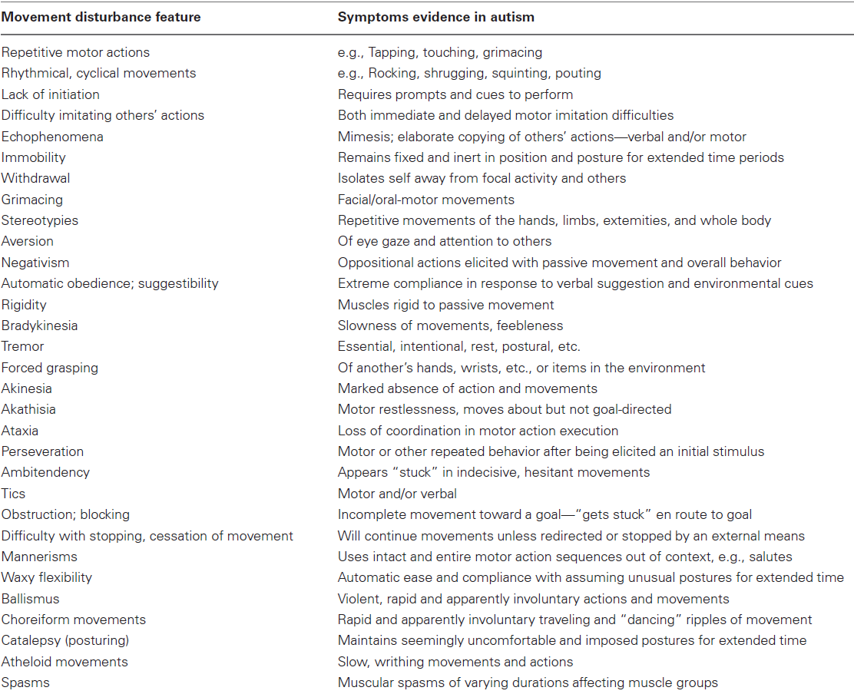

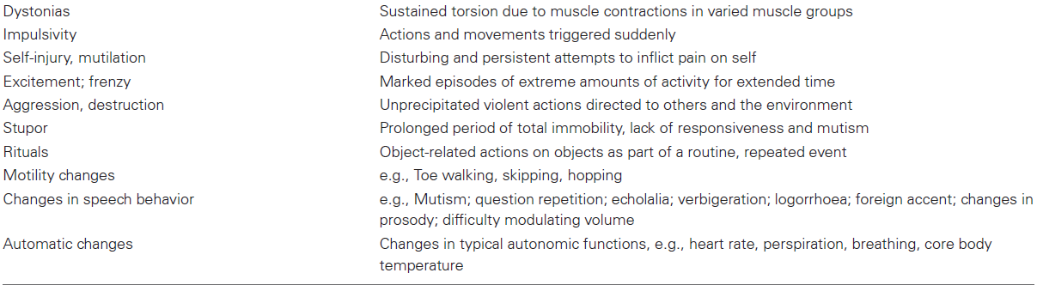

# **An Autoencoder-Based Deep Learning Classifier for Efficient Diagnosis of Autism**

-> Various machine learning and deep neural network methods distinguish between ASD and non-ASD. These methods are categorized into three main categories as

- Image-based (by using large brain image datasets from ABIDE)

- Questionnaire-based (using crowdsource requirement procedure)

- Behavioural-based

-> This paper proposed to classify ASD for diagnosis using an autoencoder hybrid classifier

-> The input data is 1112 fMRI images from ABIDE

-> Autoencoder is used for dimensionality reduction. This methodology proposed in this paper is :   
- First input data is given to the undercomplete autoencoder  
- The output of the autoencoder is then given to various machine and deep learning models such as CNN, KNN, SVM, RF

- The result of all these models are compared

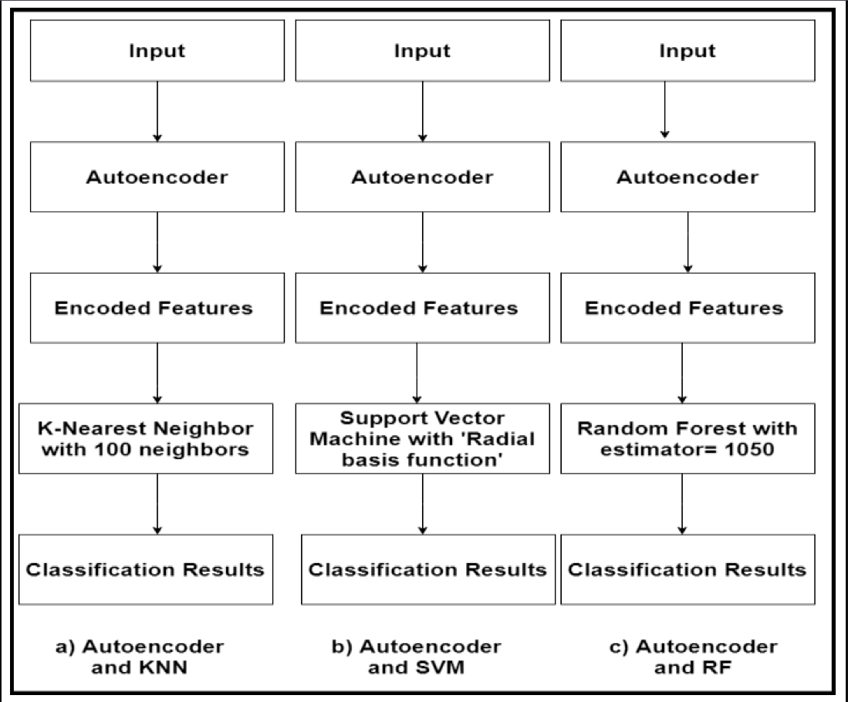

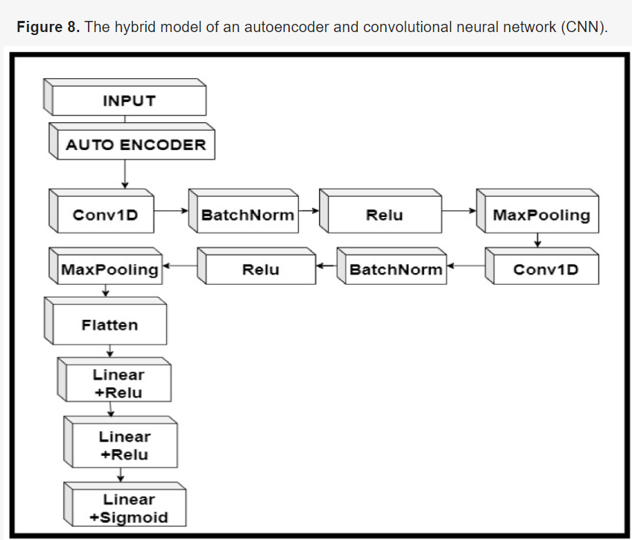

-> The hybrid of autoencoder and CNN was the most accurate in classification with an accuracy of 84.05%

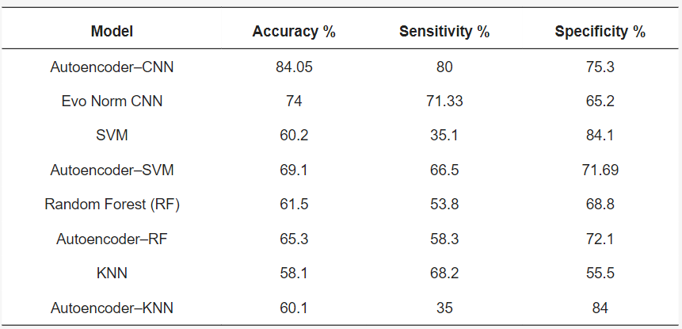

-> Percentage of improvement in accuracy, sensitivity and specificity

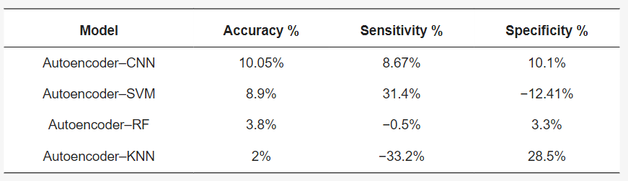

-> They also found out that using an autoencoder and a classifier as a hybrid model is more successful and accurate than just using a classifier alone

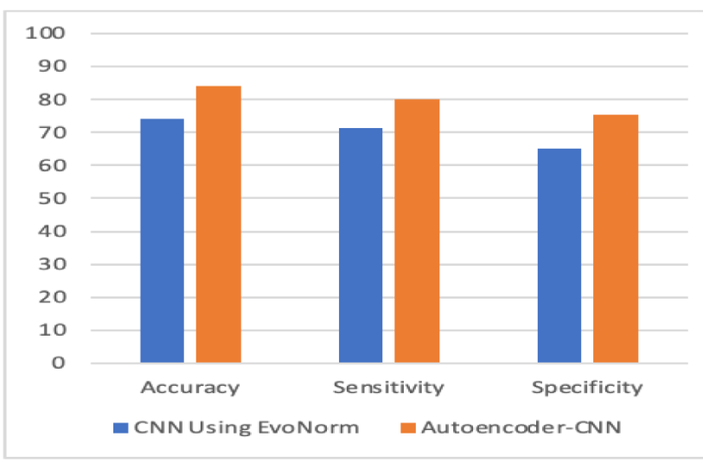

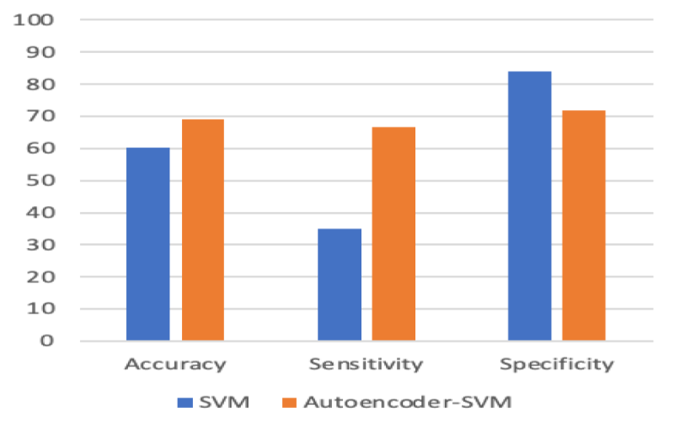

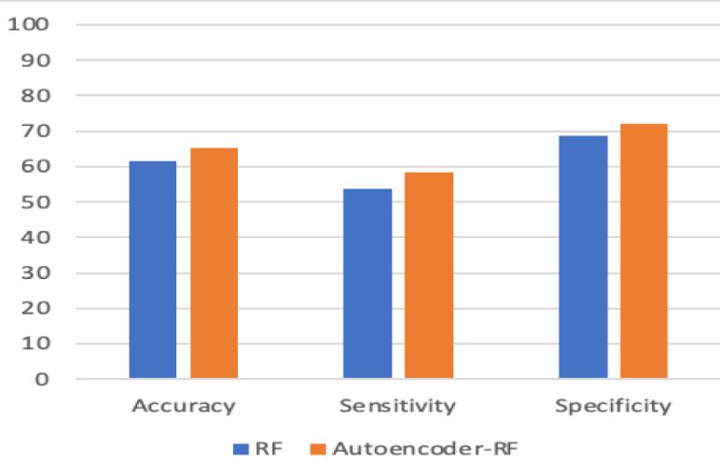

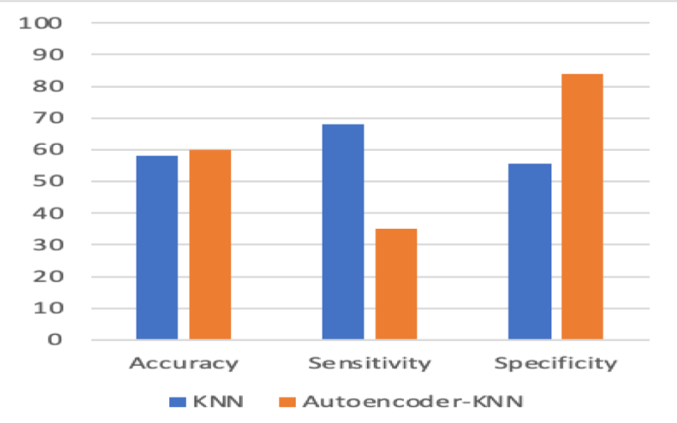

-> The ROC(receiver operating characteristics) curve and AUC(area under curve) for autoencoder-CNN hybrid was better than any other model

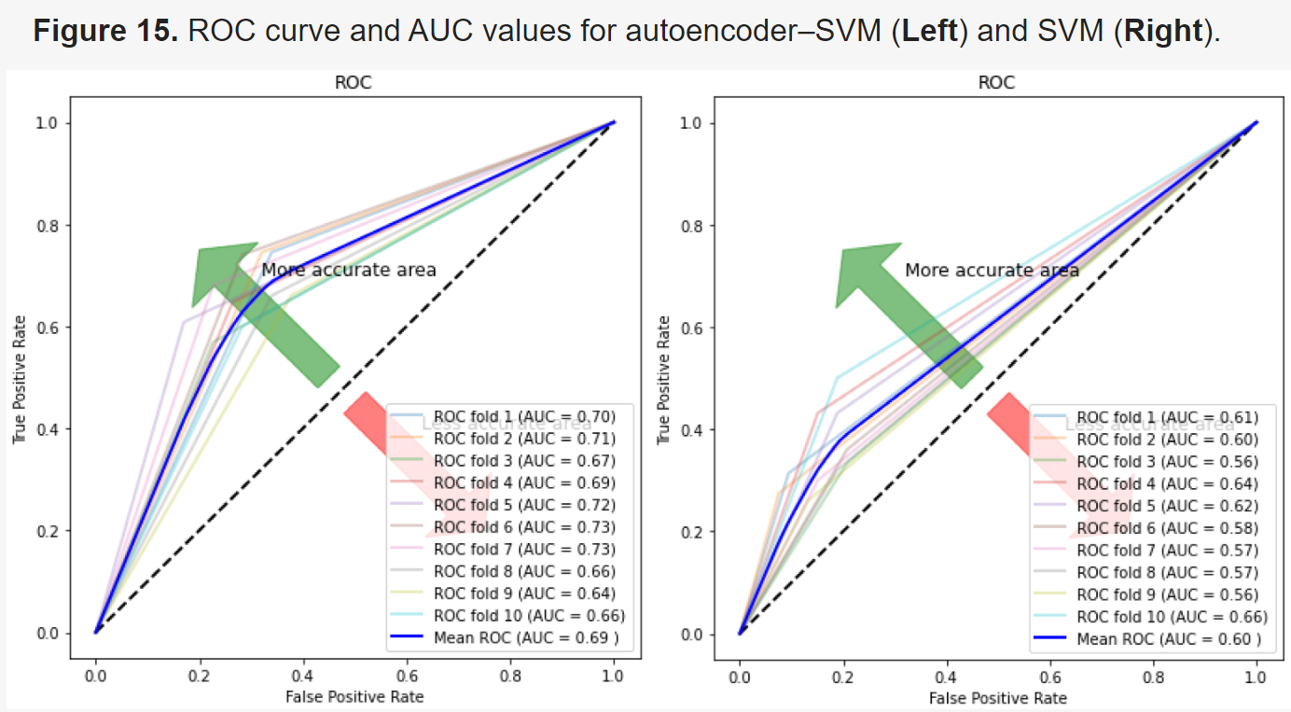

-> The ROC curve and AUC is better for all the hybrid models compared to their non hybrid classifiers

-> The autoencoder-CNN hybrid also achieved better F1 score than all other models

F1 = 2×(𝑝𝑟𝑒𝑐𝑖𝑠𝑖𝑜𝑛×𝑟𝑒𝑐𝑎𝑙𝑙)/(𝑝𝑟𝑒𝑐𝑖𝑠𝑖𝑜𝑛+𝑟𝑒𝑐𝑎𝑙𝑙)

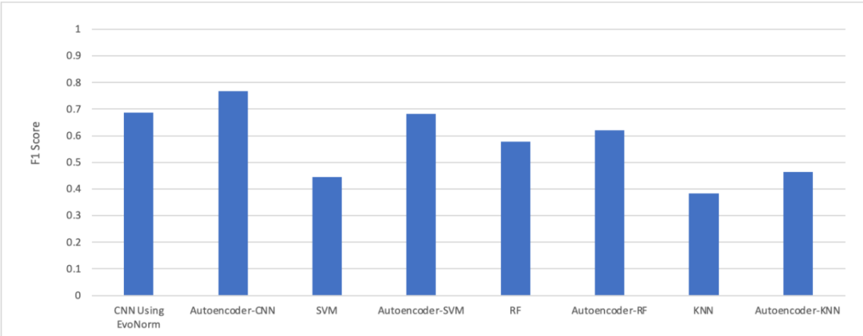

-> The autoencoder-CNN hybrid took the most computational time for training compared to other models

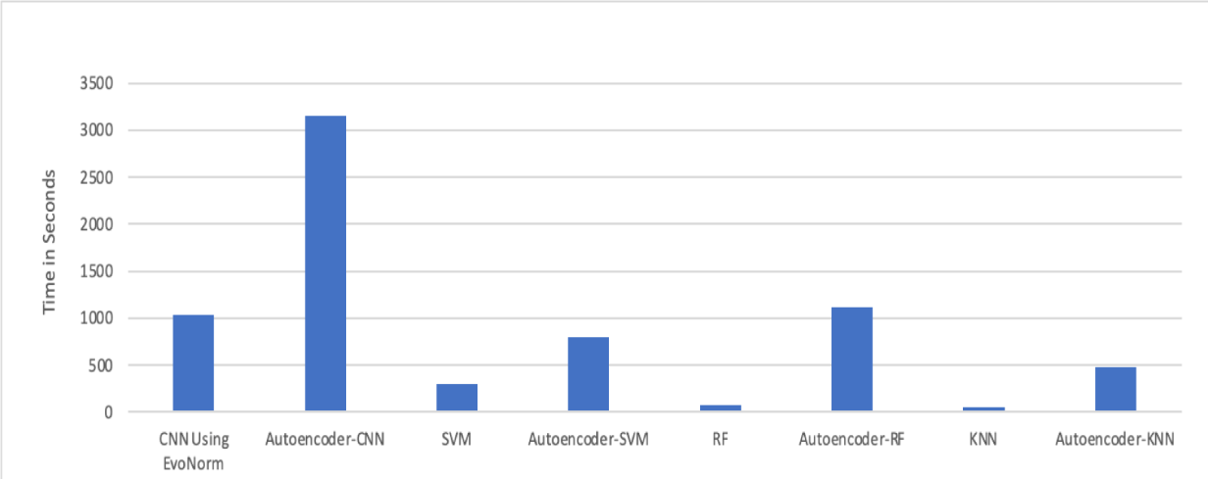

1. **Deep learning for neuroimaging-based diagnosis and rehabilitation of Autism Spectrum Disorder: A review**

**DOI: 10.1016/j.compbiomed.2021.104949**

-> Neuroimaging techniques are non-invasive disease markers potentially useful for ASD diagnosis

-> Structural and functional neuroimaging techniques provide physicians substantial information about the structure (anatomy and structural connectivity) and function (activity and functional connectivity) of the brain

-> past ASD was divided into five groups: Asperger’s syndrome (AS), Rett syndrome (RS), childhood disintegrative disorder (CDD), autistic disorder (classic autism), and pervasive developmental disorder – not otherwise specified (PDD-NOS)

-> current ASD classification is now categorized into 3 security levels

Level 1 - Needs support

Level 2 - Needs substantial support

Level 3 - Needs very substantial support

-> transcranial magnetic stimulation (TMS) is a non-invasive brain stimulation method based on electromagnetic induction that concentrates on the brain areas that play an essential role in adjusting the behavior of ASD patients

-> transcranial direct current stimulation (tDCS) is a non-invasive brain stimulation method that employs direct electric currents to stimulate certain parts of the brain

-> various tools that psychiatrists use are as follows

* autism diagnostic observation schedule 2nd edition (ADOS-2)
* autism diagnostic interview-revised (ADI-R)
* childhood autism rating scale (CARS)
* diagnostic interview for social and communication disorder (DISCO)
* Gilliam autism rating scale (GARS)
* developmental, dimensional, and diagnostic interview (3di)
* modified checklist for autism in toddlers (M-CHAT)

-> datasets -> ABIDE I and ABIDE II

-> pre processed dataset -> PCP and MLLE

-> total 1114 entries

-> another dataset used is EEG dataset by King Abdulaziz University (KAU) Brain Computer Interface (BCI) Group

-> various data preprocessing is done and classified into 2

* Standard (low-level) fMRI preprocessing steps
* Standard (low-level) sMRI preprocessing steps
* High-level preprocessing steps
  + Brain extraction
  + Spatial smoothing
  + Temporal filtering
  + Motion correction
  + Slice time correction
  + Intensity normalization
  + Registration to a standard atlas
  + neuroimaging analysis kit (NIAK)
  + data processing assistant for rs-fMRI (DPARSF)
  + the configurable pipeline for the analysis of connectomes (CPAC)
  + connectome computation system (CCS)
  + Denoising
  + Inhomogeneity correction
  + Intensity standardization
  + De-oblique
  + Re-orientation
  + Segmentation
  + sliding window (SW)
  + data augmentation (DA)
  + functional connectivity matrix (FCM) estimation
  + fast Fourier transformation (FFT)

-> CNN, RNN, AE, DBN, CNN-RNN, and CNN-AE models are examined in this review

-> data such as sMRI, DTI, rsfMRI, T-fMRI, fNIRS, and EEG with their data in 1D, 2D, and 3D format are explored.

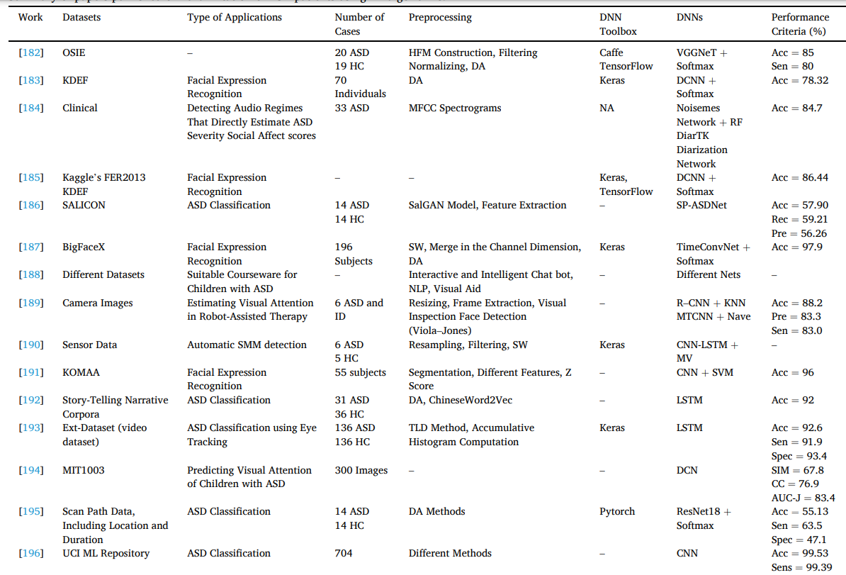

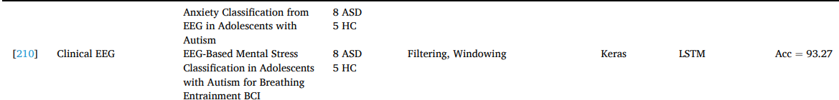

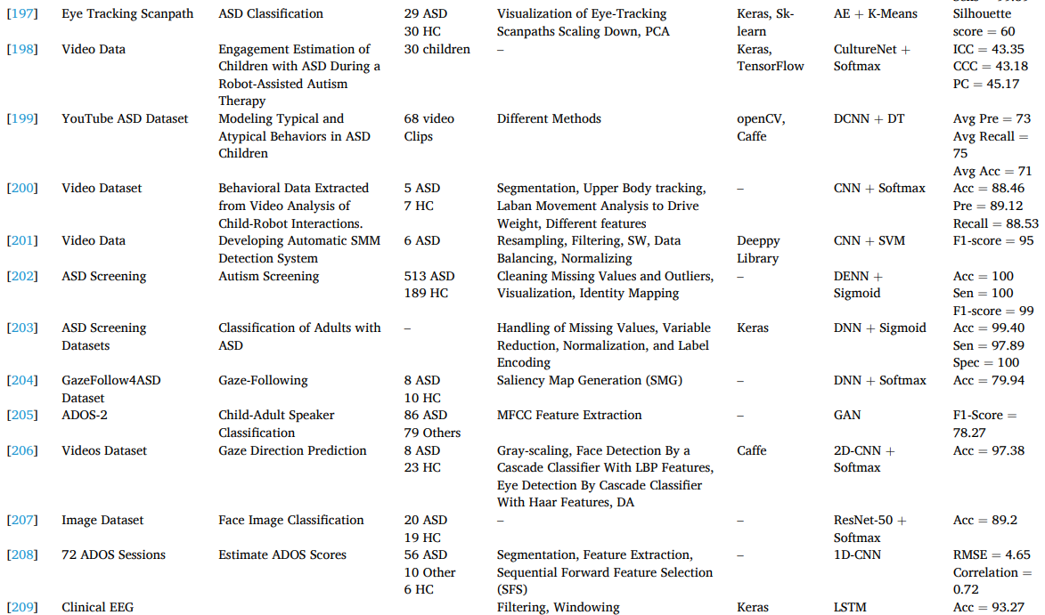

1. **PREDICTING AUTISM DIAGNOSIS USING IMAGE WITH FIXATIONS AND SYNTHETIC SACCADE PATTERNS**

**DOI: 10.1109/ICMEW.2019.00125**

-> First signs of ASD appears early to under age of 3

-> most diagnosis interviews happen after age 3 (it is done at age 4 in USA)

-> this paper presents the need for early diagnosis of ASD in toddlers and children under the age of 3 when the brain is most malleable.

-> proposes 2 DL model techniques

-> both uses the [Gaze dataset](https://zenodo.org/records/2647418)

-> generative model of synthetic saccade patterns STAR-FC

-> in STAR-FC, the model generates the scanpath for the typically developed(TD) childrens and adds the inputted scanpath of the children to the input for the classifier

-> in the second approach, the image + the fixation heat map is fed into the CNN network for learning

-> “a deep neural network has been jointly trained on real scan path in conjunction with synthetic scan path generated by STAR-FC. Since STAR-FC is trained on general population, it is assumed that it models the scan path of TD subjects.”

-> the data consists of timestamps, x-y coordinates, horizontal and vertical eye gaze coordinates.

-> these data are then combined into scan paths by connecting with 3 different distance measures

-> Dynamic Time Warping (DTW), Hausdorff distance and Frechett distance are computed between the normalized real and synthetic scan-path

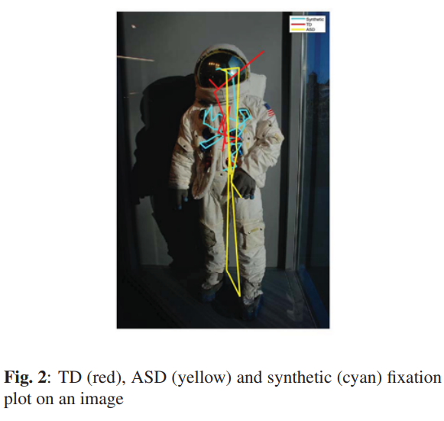

Example data ^

-> 2 fully connected dense networks are trained separately

-> the first model has reduced set of high level features

-> 7 features => duration, total number of fixation points, mean, variance, three distance measures (DTW, Hausdorff, Frechett) => 7 dimensional input features

-> input layer has batch normalization

-> 8 fully connected layer with 7 neurons each and SELU activation has been applied

-> output layer has one-hot coded (probably 2 neurons TD and ASD)

-> trained for 200 epochs, binary cross entropy loss function and L2 regularizer with ADAMs optimizer

-> batch size = 128, has 492 trainable parameters

-> second model is a deeper network with 10 fully connected layers

-> the input vector dimension is 1D with 47 elements, with the previous 7 and the 20 points from real scanpath and the 20 points from synthetic scanpath.

-> input -> 128 -> 256 -> 512 -> 1024 -> 512 -> 128 -> 64 -> 16 -> output

-> output is one-hot coded

-> batch normalization and dropout of 0.3 have been applied on all hidden layers

-> 300 epochs, 0.001 learning rate, batch size = 32, 1402560 trainable parameters

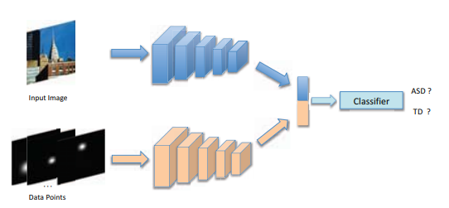

-> the network is split into 2 branches

-> first part extracts the features of the images

-> second part processes the data points

-> the data points are gaze points D = {(x, y, d)} where (x, y) is the data point and d is the duration of Gaze

-> two branches are fused together to classify output

-> 300 images, 6050 samples, 80-20 split for validation

-> some noise has been added to both the input image and the data points, since the dataset is small and to avoid overfitting

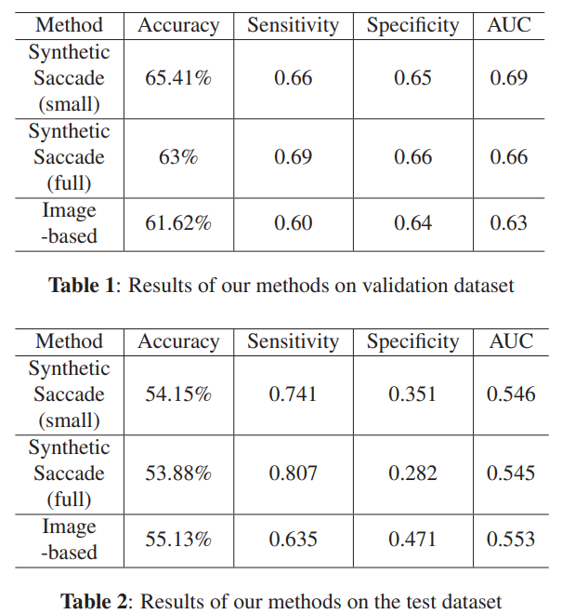

-> from the results, we can infer that training and testing data was imbalanced and due to the noise added in the data augmentation part the model couldnt learn the features properly. Also to note that the dataset only contains 300 images thus with reduced data the model was only able to learn this much

# **Eye Tracking-Based Diagnosis and Early Detection of Autism Spectrum Disorder Using Machine Learning and Deep Learning Techniques**

**DOI: 10.3390/electronics11040530**

-> Dataset: Figshare data repository

<https://figshare.com/articles/dataset/Visualization_of_Eye-Tracking_Scanpaths_in_Autism_Spectrum_Disorder_Image_Dataset/7073087/1>

-> 547 images of asd with 219 ASD and 328 TD children

-> proposes 3 techniques in the paper

-> ML model, DL model, a hybrid between the 2

* + FFNN and ANN based on local binary pattern LBP and gray level co-occurrence matrix GLCM
  + Pre-trained CNN -> GoogleNet and ResNet-18
  + GoogleNet+SVM and ResNet-18+SVM

-> classification problem -> classes: lower SVA and TD (SVA: social visual attention)

-> The data is first processed

-> Pre-processing -> applying Average and Laplacian filters of 5x5

-> Segmentation and feature extraction

-> a snake model was applied for segmentation, extracting ROIs and isolation of them

-> from that LBP and GLCM was used for feature extraction

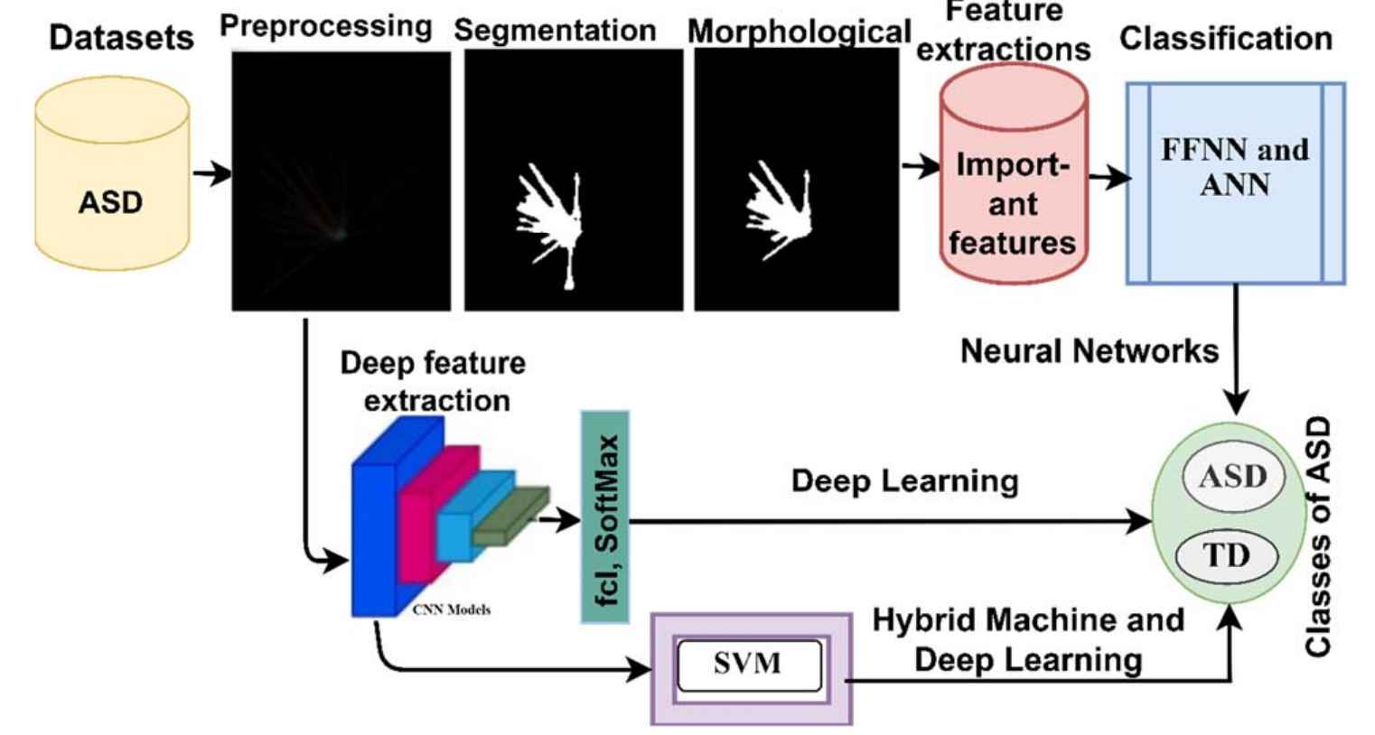

-> morphological method contain 2 processes => ‘fits’ and ‘hits’

-> fits => adjacent union test and hits => tests the adjacent intersection

-> this morphological method produced improved binary images

-> in the first method, the ANN contains 10 FC dense layers with 216 neurons

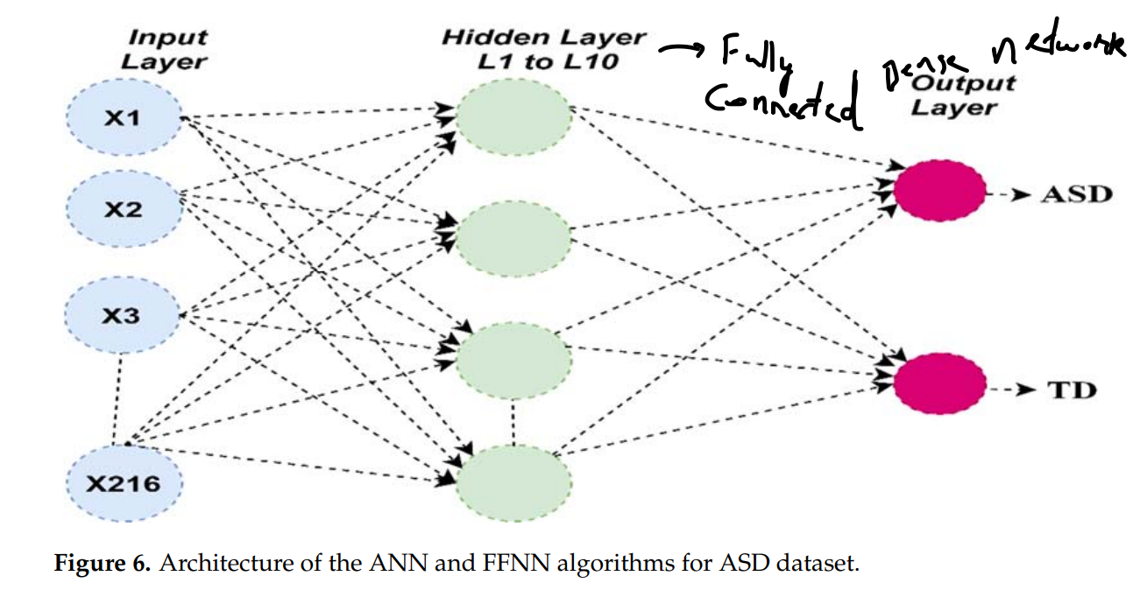

-> the second method uses the pre trained models GoogleNet and ResNet-18

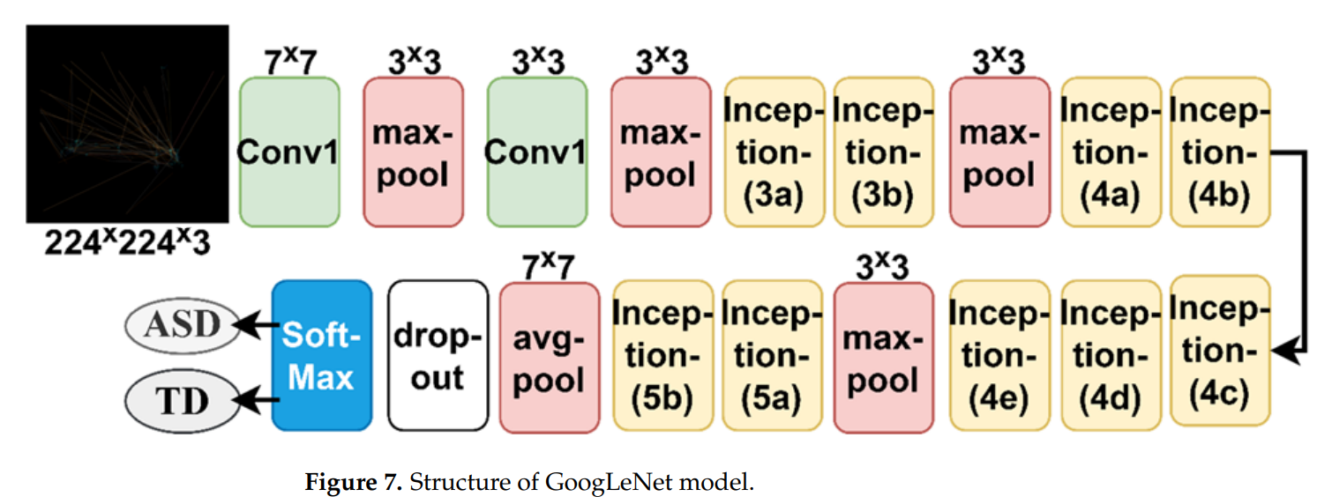

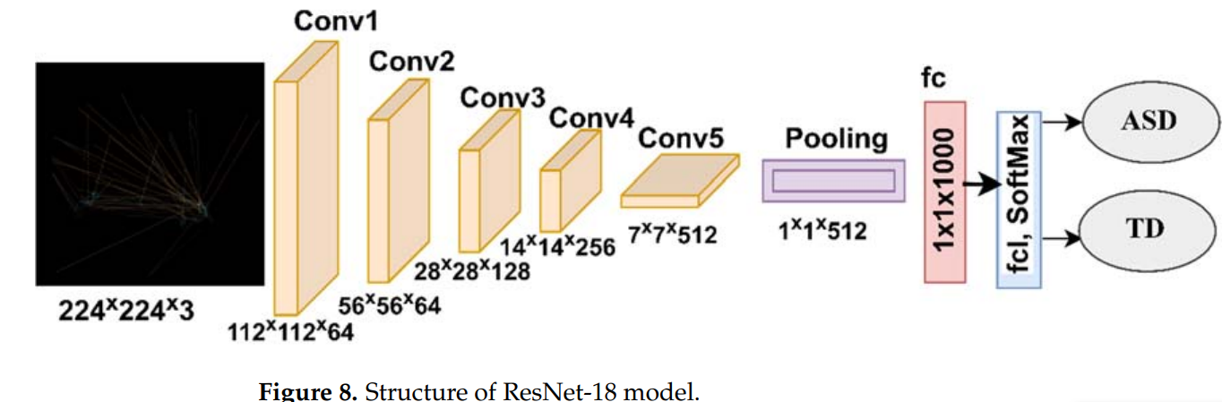

-> the third method just removes the last fully connected layer with SoftMax activation and replaces with the SVM block for classification

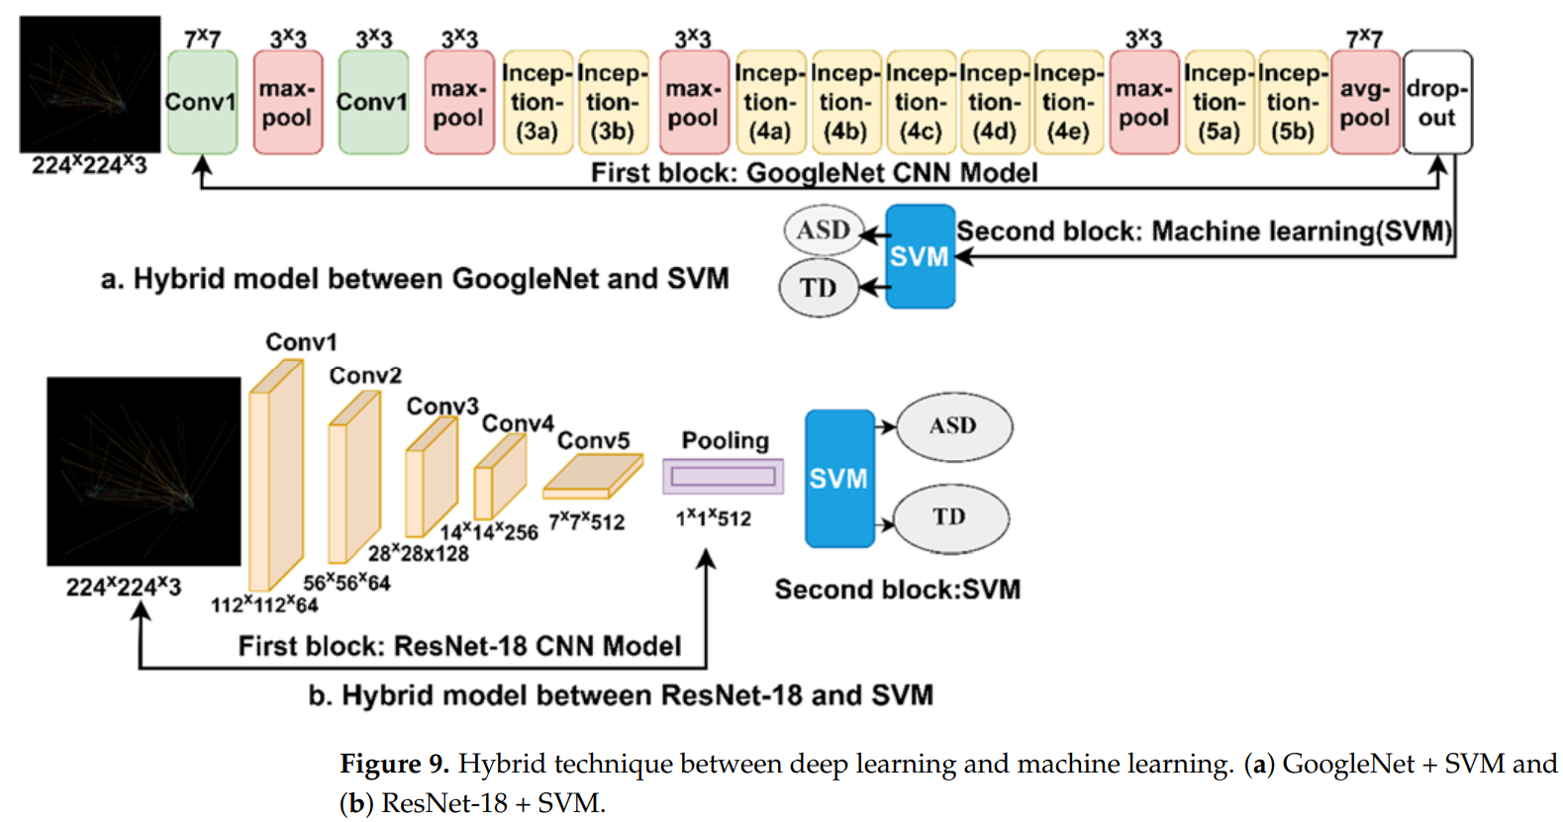

-> the data was split in 80-20 ratio -> 80 for training and 20 for testing

-> further divided the training data into training and validation with 80-20

-> the data was split in the ratio 64% **:** 16% **:** 20% - Training **:** Validation **:** Testing

-> the evaluation metrics used are as follows

Accuracy

Precision

Sensitivity

Specificity

AUC

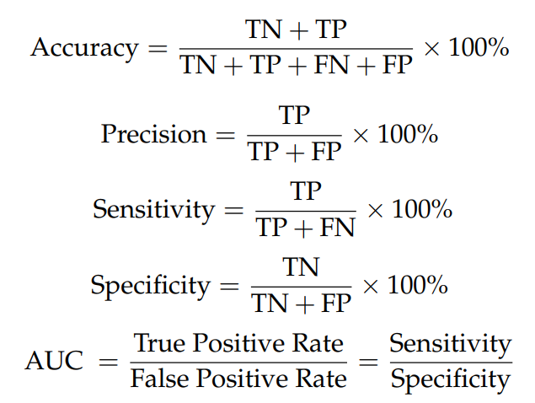

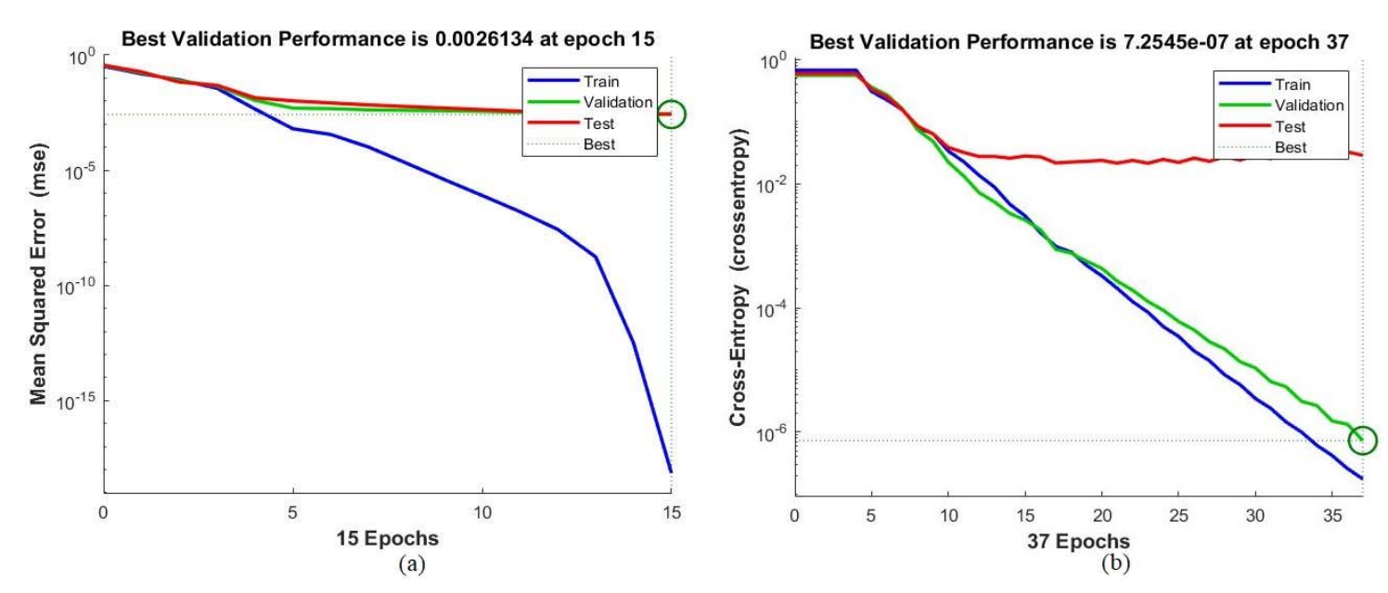

ROC(Receiver operating characteristics) was found to be 99.77%

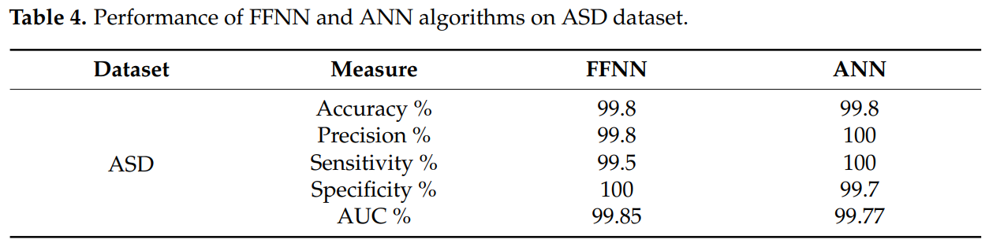

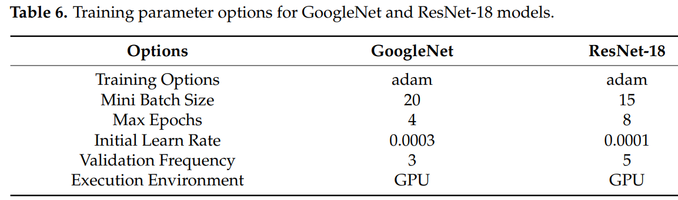

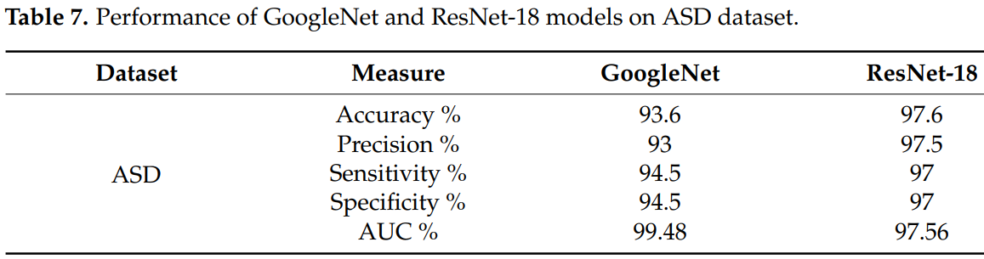

1. **Vision-based activity recognition in children with autism-related behaviors**

-> ASD diagnosis, preprocessed data, collected data, human detection, background removal, temporal convolutional models, light weight, Inflated 3D convnet and Multi Stage Temporal Convolutional Network, Weighted F1 score = 0.83, 3 activities, ESNet backbone weighted F1 score =0.71, uncontrolled Environment

-> [“ASD is a neurodevelopmental disorder characterized by a set of social communication deficits, self-harm, or persistent repetition of actions”](http://refhub.elsevier.com/S2405-8440(23)03970-1/bibABB7B79D860AFD1314264C986AF4606Cs1)

-> “ASD related biomarkers such as those determined through functional magnetic resonance imaging (fMRI). [Facial expressions](http://refhub.elsevier.com/S2405-8440(23)03970-1/bibD2F6BC878DD136CE1116D13D2DF5BCA9s1), [eye gaze, and motor control/movement patterns](http://refhub.elsevier.com/S2405-8440(23)03970-1/bibF685F61EDB75CC4742D43DD621AEA962s1)”

-> dataset from SSBD from [rajagopalan et al](http://refhub.elsevier.com/S2405-8440(23)03970-1/bibA1DD584B1FB446E21CB1B438E6012CB9s1).

-> 75 videos from yt, rajagopalan et al provides no other novel methods other than the “new Self-Stimulatory Behavior Dataset (SSBD) for ASD”

-> additionally added videos from online platforms => not mentioned sources

-> Feature extraction (CNN model) => action classification (TCN)

-> dataset transformed into 168 short clips after removing noisy data and adding new data

-> [168 clip dataset](https://github.com/Samwei1/autism-related-behavior/blob/main/url_list.pdf)

-> “used compressed feature representation for real time throughput”?

-> two crucial steps:

i) a feature extractor that extracts frame-wise action-related semantic features

ii) an action recognition model which recognizes autism-related behaviors by modeling the temporal evolution of the extracted frame-wise features.

|  |  |  |
| --- | --- | --- |
| Feature Extractor Backbone | Pros | Cons |
| EfficientNet | - Computationally efficient compared to ResNet, I3D, etc. - Robust features due to the compound scaling mechanism | - Not suitable for mobile applications. |
| MobileNet | - Computationally efficient. - Does not require an impressive amount of data to train. - Suitable for mobile and embedded vision applications. - Low computational resources are required. | - Limited model capacity to learn large-scale data. - Produce less accurate results compared to EfficientNet, ResNet and I3D |
| ShuffleNet | - Computationally more efficient than MobileNet. - Does not require an impressive amount of data to train. - Suitable for mobile and embedded vision applications. - Low computational resources are required. - More accurate than MobileNet. | - Limited model capacity to learn large scale complex data. |
| ESNet | - Computationally more efficient than MobileNet and ShuffleNet. - Real-time performance. - Suitable for mobile and embedded vision applications. - Does not require an impressive amount of data to train. - Low computational resources are required. | - Limited model capacity to learn large scale complex data. |
| ResNet | - Produce more accurate results than the shallow networks - Suitable for learning large-scale complex data. - The residual connections overcome the vanishing gradient problem. | - Requires more memory and computational resources, which makes it less suitable for mobile applications. |
| I3D | - More suitable for video-based applications to capture spatio-temporal features. - Suitable for learning large-scale complex data. - Produce more accurate results than shallow networks such as MobileNet etc. | - Requires more memory and computational resources, which makes it less suitable for mobile applications. |

-> Comparing 7 feature extractors and 4 learning strategies-> We select feature extractors appropriate for two different operating conditions:   
 i) a light-weight environment condition suitable for an embedded device

ii) a standard operating condition (i.e. conventional models) suitable for a powerful workstation or server.

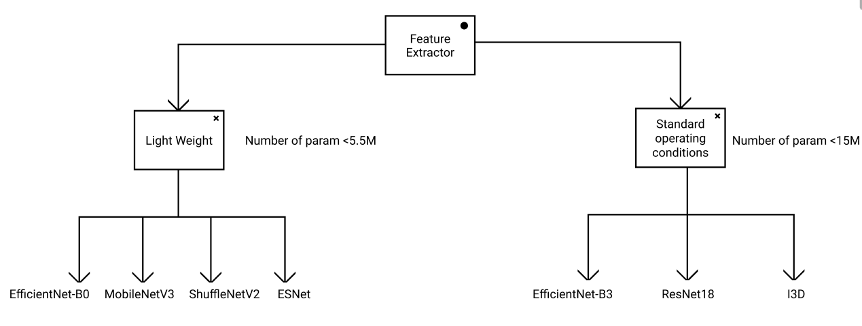

-> more complex networks  
 => ResNet101_vd 44M

=> HRNet_W48 78M

=> SwinTransformer 99M

|  |  |  |
| --- | --- | --- |
| Action Recognition Method | Pros | Cons |
| LSTM | - Has gates that control the flow of information in and out of the cell. - Low memory requirements. - Faster training. | - May suffer from the vanishing gradients when the data sequence is very long. - May overfit if not properly regularized. |
| TCN | - Able to perform temporal mapping of very long sequences well due to its multiple layers of dilated convolutions (large receptive field). - Can handle variable-length sequences. - Does not suffer from vanishing/exploding gradients. - Able to make more accurate predictions. - Faster training. | - Higher memory requirements compared to LSTM |
| MS TCN | - Achieves better results than TCN as it operates on full temporal resolution (no pooling layers are used). - Able to perform temporal mapping of very long sequences well due to its multiple layers of dilated convolutions (large receptive field). - Can handle variable-length sequences. - Does not suffer from vanishing/exploding gradients. - Multi-stage architecture provides an improved receptive field. - Faster training | - Higher memory requirements compared to LSTM |
| MS TCN++ | - Similar capabilities to MSTCN, however, MSTCN++ achieves better results than MSTCN due to the dual dilated layer. | - Higher memory requirements compared to LSTM |

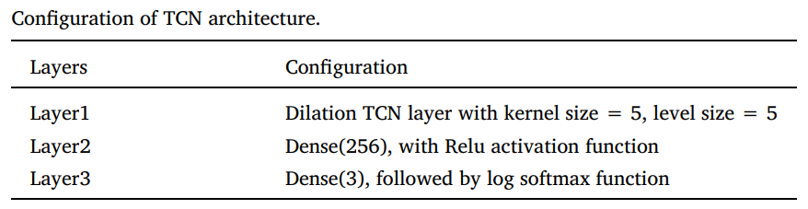

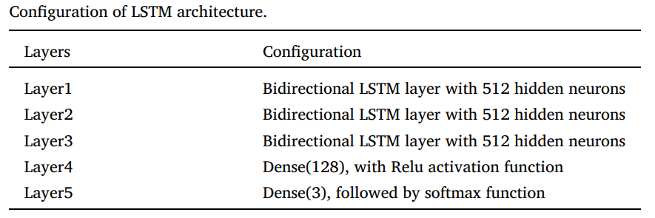

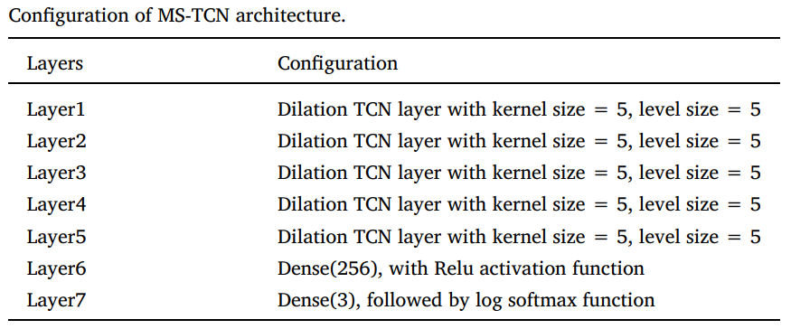

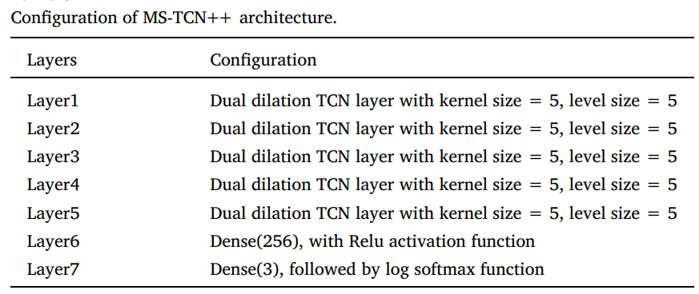

-> result

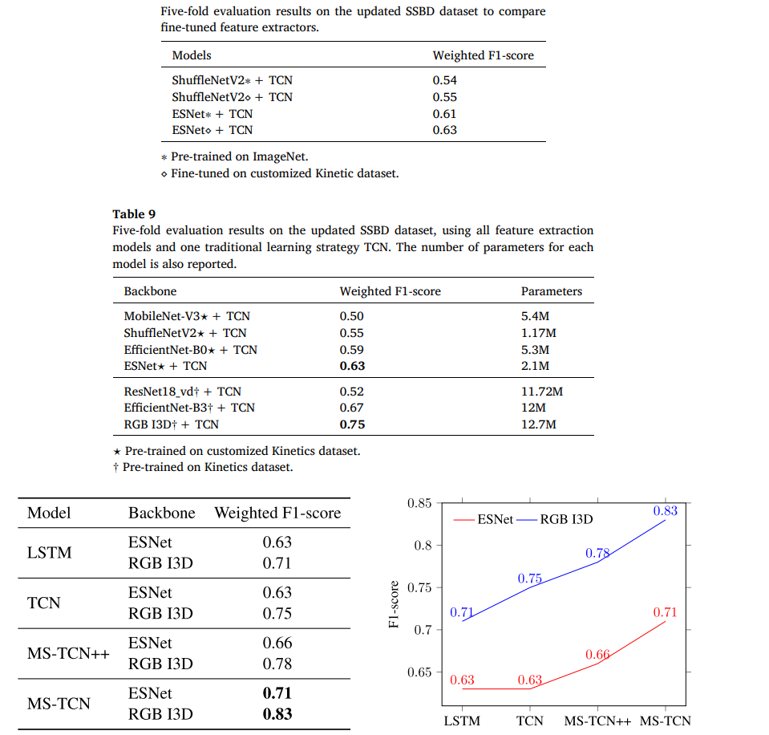

-> The experimental procedures involving human subjects described in this paper were approved by the CSIRO Health and Medical Human Research Ethics Committee (CHMHREC). The CHMHREC is an NHMRC Registered Human Research Ethics Committee (EC00187). CSIRO Ethics ID 2022_004_LR

-> The SSBD dataset contains three typical action classes: [arm flapping, headbanging, and spinning](http://refhub.elsevier.com/S2405-8440(23)03970-1/bib4D9D9730B08D8B0C61D9383EE9EEA541s1)

-> pre processing of dataset by cropping the subject alone and removing noisy data from the database

-> pre processing done by a [Mask-RCNN](http://refhub.elsevier.com/S2405-8440(23)03970-1/bib08C68D5A15B6099E3974E116F67B7866s1) pretrained on [COCO](http://refhub.elsevier.com/S2405-8440(23)03970-1/bibC01EB5E415C8DE0E0940FB894AA903ECs1) and implemented through [Detectron2](https://github.com/facebookresearch/detectron2), then resized to a fixed size using the bounding box size

-> 5-fold validation and “Leave-One-Group-Out” setting

-> mean Weighted F1-score for 5-fold validation

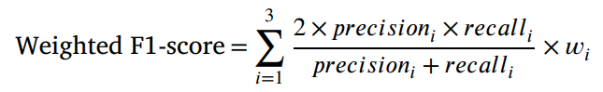

-> 200 epochs, batch size=16, learning rate=e^-3, first moment decay rate=0.9, second moment decay rate=0.999

1. **Activity Recognition with Moving Cameras and Few Training Examples: Applications for Detection of Autism-Related Headbanging**

-> ASD Diagnosis, preprocessed data, collected data, OpenPose realtime multi-person pose estimation, estimated skeletal pose, extracting key points in the head region for accuracy, convolutional neural network (CNN) using the Keras [10] Python library with a Tensorfow [1] backend, a long short-term memory (LSTM) [28] neural network, 3-fold cross validation, 90.77% across the 3 cross-validation folds. The individual F1-scores per fold are 83.3%, 89.0%, and 100.0%.

* -> [“ASD is a neurodevelopmental disorder characterized by a set of social communication deficits, self-harm, or persistent repetition of actions”](http://refhub.elsevier.com/S2405-8440(23)03970-1/bibABB7B79D860AFD1314264C986AF4606Cs1)
* -> “ASD related biomarkers such as those determined through functional magnetic resonance imaging (fMRI). [Facial expressions](http://refhub.elsevier.com/S2405-8440(23)03970-1/bibD2F6BC878DD136CE1116D13D2DF5BCA9s1), [eye gaze, and motor control/movement patterns](http://refhub.elsevier.com/S2405-8440(23)03970-1/bibF685F61EDB75CC4742D43DD621AEA962s1)”
* To minimize overfitting, rotation at a random interval between -45 and 45 degrees and zooming in with a random zoom factor between 1.0 and 2.0.
* dataset from SSBD from [rajagopalan et al](http://refhub.elsevier.com/S2405-8440(23)03970-1/bibA1DD584B1FB446E21CB1B438E6012CB9s1).
* 27 video clips containing headbanging video clips containing “normal” head motions.
* OpenPose realtime multi-person pose estimation to track skeletal keypoints in each frame
* To account for the body part occlusion issue, which would inject unnecessary noise which would confuse the classifer
* extracting key points in the head region.
* We implement a time-distributed convolutional neural network (CNN) using the Keras [10] Python library with a Tensorfow [1] backend.
* We train using Adam optimization [34] with an initial learning rate of 0.0001.
* We perform 3-fold cross validation, ensuring that no child who appeared in the train set would appear in the test set for all folds.
* To minimize overftting and increase generalization, we apply the following data augmentations to each frame: rotation at a random interval between -45 and 45 degrees and zooming in with a random zoom factor between 1.0 and 2.0.

**Pros And Cons of Dense Optical Flow:**

Pros : Dense optical fow computes fow for all points in a frame, resulting in “flow vectors” with a magnitude and direction.

Cons : extra non-relevant movement patterns add much noise to the dense optical fow image, making it a non-ideal representation.

**Pros And Cons of Lucas Kanade Optical Flow:**

Pros : Lucas-Kanade optical fow, in contrast to dense optical fow, computes fow for a sparse number of points pre-defned by the user [3], for example detected edges or corners.

Cons:The Lucas-Kanade method brings its own set of limitations by detecting movement outside of the body to an extent that is more dramatic than dense optical fow. This technique is particularly sensitive to background movement detection associated with slight shifts in the camera.

**Pros And Cons of Pose Estimation:**

Pros: Pose estimation is a technique which is more robust to camera movement compared to optical flow. . OpenPose uses a CNN which is trained to predict part afnity felds, or fow felds representing relationships between body parts, and confdence maps which encode body part locations. Unlike optical fow, OpenPose predicts each frame independently of the surrounding frames.

Cons: There are some clear limitations to using unmodifed pose estimation. The noisy skeleton problem is a documented issue which arises when body parts are self-occluded. We observe that body part occlusion is a frequent occurrence in unstructured home videos, making unmodifed pose estimation a non-ideal feature representation.

1. **Application of Skeleton Data and Long Short-Term Memory in Action Recognition of Children with Autism Spectrum Disorder**

-> asd diagnosis, skeletal data + LSTM

-> OpenPose algorithm for skeletal data

-> 4 denoising techniques applied to skeletal data before passing to stage 2

-> stage 2 = tracking humanoids based on temporal data

-> stage 3 = LSTM classification

-> OpenPose + denoising > tracking > classification

-> [characterized by persistent deficits in social communication and interaction as well as restricted and repetitive behaviors](https://sci-hub.live/10.1016/b978-0-12-809324-5.05530-9)

-> First, we scale the coordinates of the key points outputted by OpenPose to the same units

-> Second, we remove the five joints on the head

-> Third, we discard frames without skeleton data or missing important joints.

-> Finally, we use the relative joint positions in adjacent frames to fill in the unrecognized joint positions

-> head joints provides less information on the activity classification, thus they removed the head joints from the maps

-> frames with major joints missing will be discarded

-> other joints missing will be filled in by the temporal frames adjacent to them

-> facilitates tracking of multiple skeletons

-> DeepSORT and SORT are computationally expensive

-> a new algorithm is developed which finds the distance of the joint i of the jth person id and calculates the relative position to the frame’s center, this location is compared with adjacent temporal frames to identify if it is the same person for tracking the skeleton

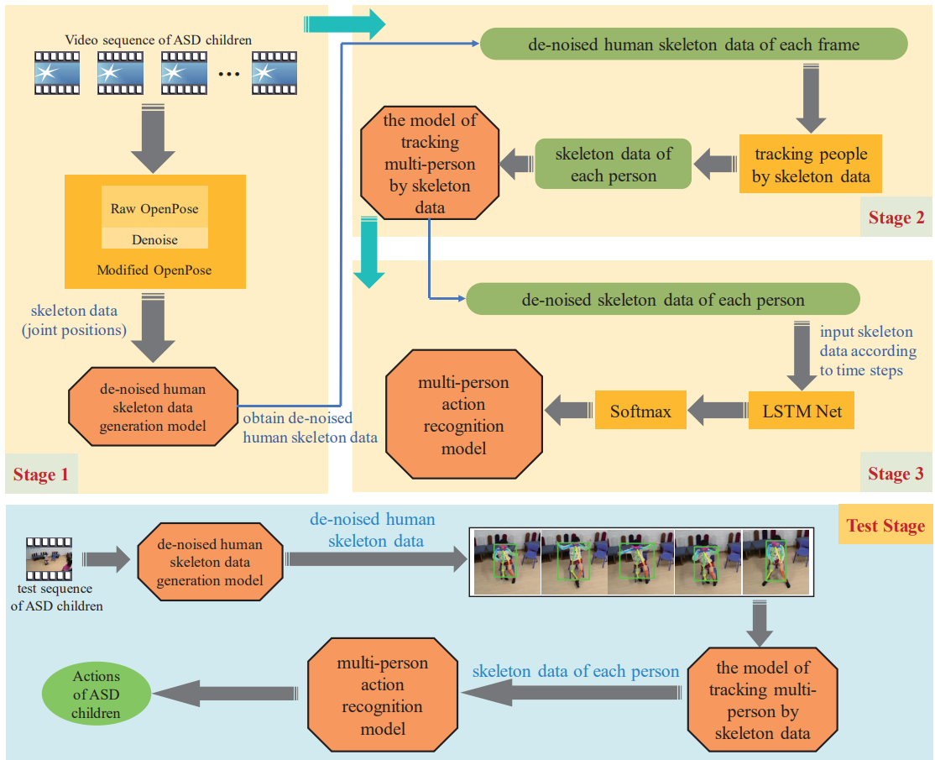



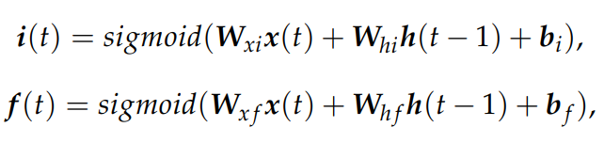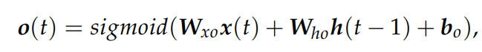  
  
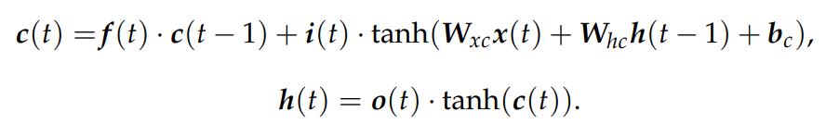

-> collected data, 5 actions, sit stand squat shake body shake hands, 1062 sequences

-> normalized to 656x368 -> sent to OpenPose

-> for training the model, only one subject should taken in case of multiple subjects in frame, the subject closest to the center of the frame was taken

-> 70-30 split, 32x13x2, 32 frames, 13 skeletal key points, 2 x-y coordinates

-> hidden states = 128, learning rate =0.001, time steps =32, prob_threshold=0.9

-> mentioned [AlphaPose](https://ieeexplore.ieee.org/abstract/document/9954214/) is also a good method to implement

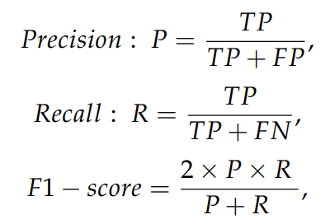

-> Compared other methods

-> DNN, SVM, decision tree, RF

-> F1 score is used for performance metric

Action Original De-noised

Sit 0.734 0.8868

Stand 0.9279 0.9896

Squat 0.7757 0.8925

Shake body 0.8604 0.9415

Shake hand 0.9094 0.9803

1. **Automated Detection Approaches to Autism Spectrum Disorder Based on Human Activity Analysis: A Review**

**-Datasets Used-**

**Skeleton Dataset :**

[Rihawi et al](https://ieeexplore.ieee.org/abstract/document/8078544?casa_token=omwAbF501e0AAAAA:QQmTyOr5DqGqc2a3c4yX5Zg-AYK24Pi5ASYaLAjbBnkarUt4BagYN_YnVTohfbxjRFIkhQ0U8rU5). developed the first publicly available 3D dataset named ‘3D-AD’ based on ASD subjects using the Kinect-v2 camera. This dataset includes depth maps, which have been captured at 33 frames per second. The sequence of skeleton joint features was collected for ten different actions, e.g., hands-on the face, hands back, hand moving front of the face, headbanging (or rocking back and forth), tapping ears, flicking, hands stimming, toe walking, playing with a toy, and walking in circles. This research reported Dynamic Time Wrapping (DTW) distance as a distinguishable feature to detect ASD and TD.

[Al-Jubouri et al.](https://www.researchgate.net/profile/Ahmed-Abdulrahman-6/publication/344044462_GENERATING_3D_DATASET_OF_GAIT_AND_FULL_BODY_MOVEMENT_OF_CHILDREN_WITH_AUTISM_SPECTRUM_DISORDERS_COLLECTED_BY_KINECT_V2_CAMERA/links/5f4f91b1458515e96d22fca7/GENERATING-3D-DATASET-OF-GAIT-AND-FULL-BODY-MOVEMENT-OF-CHILDREN-WITH-AUTISM-SPECTRUM-DISORDERS-COLLECTED-BY-KINECT-V2-CAMERA.pdf) have published a publicly available 3D skeleton-based gait dataset of 50 children with Autism and 50 typically developing (TD) child. In the video data captured in Kinect v2, the participant walked along a line at their normal speed. The skeletal data included the joint position of 25 three-dimensional joint positions, sixteen angles and on gait cycle from 2 or more feature extracted from the data. Diferent data augmentation techniques: Jittering, Scaling, translation, Flipping and slicing were used to increase the diversity of data.

**Video Dataset :** [Zunino et al.](https://ieeexplore.ieee.org/abstract/document/8545095?casa_token=t7wb3xJdNH0AAAAA:w8fXgt9CFsY3EVGvJgpDViXN0ATkhhOcjPIBnbRt-oyhcXY5lCGjD_eMsK7AwbRIl0CrXqeg-Dvv) developed the only available video dataset to analyze the action style of an autistic child. The dataset includes activities such as the task of placing, picking, passing, and grasping a bottle of a particular size by an autistic child. A Vicon VUE video camera with resolution: 1280 x 720 pixels and a frame rate of 100 frames/sec was used to devise the whole experimentation. The study includes 20 TD and 20 ASD children as subjects, whose state of autism was confirmed by the DSM-5 method. All participants were in between 7 to 12 years of age.

**Gaze Dataset :** [Duan et al.](https://dl.acm.org/doi/abs/10.1145/3304109.3325818?casa_token=-Loud73uj8sAAAAA:5qGdk-Q5S0HJDnFeh1SuclTNHe3IjSo7LpmuBgcOH-kii6X0Hj6MJOW6GhX37r0-_igcD77z86c5) developed an eye movement dataset named ‘Saliency4ASD’ from 14 ASD and 14 typically developed children. All the participants were in between 5 to 12 years of age. During the eye-tracking process, the participants viewed 300 images, including natural scenes, animals, the human body, and objects. This dataset provided fixation points, fixation maps, heat maps, and scan path data of the participants.

[Yaneva et al.](https://dl.acm.org/doi/abs/10.1145/3192714.3192819?casa_token=Ss628HTZPogAAAAA:YppwDpMAn18-lXBb1_GpHeMMBO3XDBuCDyBJYMDDqm4dhA2G85eSDIXK3LU9Hdvj7SsYygAsjwPl) also developed a gaze dataset, which included autistic adults instead of children. The participants were in between 30 to 40 years of age. The experiment included 30 participants, where 15 were diagnosed with high functioning autism or Asperger’s syndrome, while the rest were non-autistic individuals. In the data collection process, the participants were asked to perform visual tasks such as web browsing and searching using a mouse and keyboard according to the given instructions. The study provided fixation time on the area of interest in images, duration of searching task in a web page, and the number of fixation points. This work utilized this dataset to classify ASD individuals and healthy people applying simple logistic regression

[Shihab et al.](https://downloads.hindawi.com/archive/2020/3407907.pdf) provided a gaze dataset that comprises face-scanning data of adults and children diagnosed with ASD. The participants were in between 4 to 60 years of age. Participants were asked to view human face images and movie clips involving social interactions on the laptop screen while the eye-tracking data were recorded using two analog cameras placed in front of the laptop. This research studied the difference in the face-scanning pattern of ASD and TD individuals and classified ASD and TD using the PCA.

**Performance Metric:**

the efficiency of a method is assessed with accuracy (i.e., ratio of the correctly labeled samples to a total number of samples), recall or sensitivity (i.e., the proportion of actual positive cases that got predicted as positive, in other words, true positive), specificity (i.e., the proportion of actual negatives, which got predicted as the negative or true negative), precision (i.e., the number of positive class predictions that actually belong to the positive class) and F1 score (i.e., the harmonic mean of the precision and recall.).

visual or graphical tools like receiver operating characteristic (ROC) curve and area under the curve (AUC) are used in measuring the performance of models.

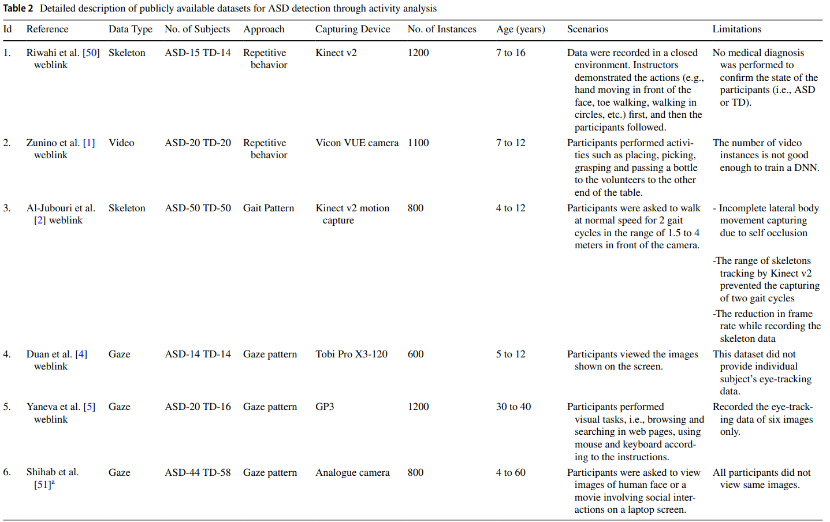

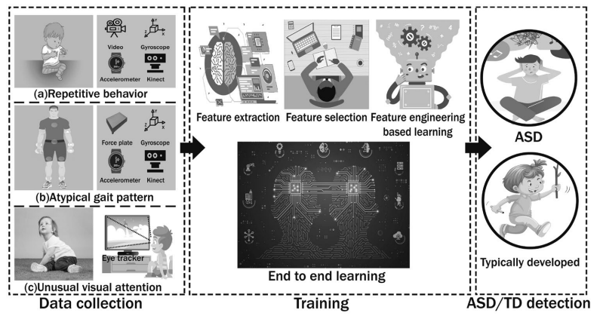

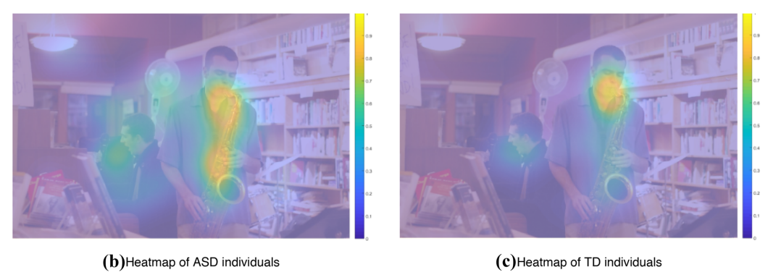

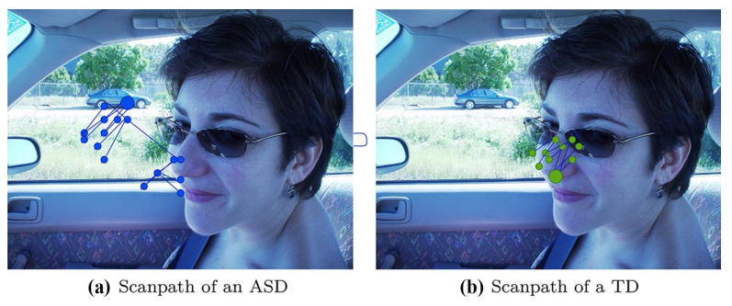

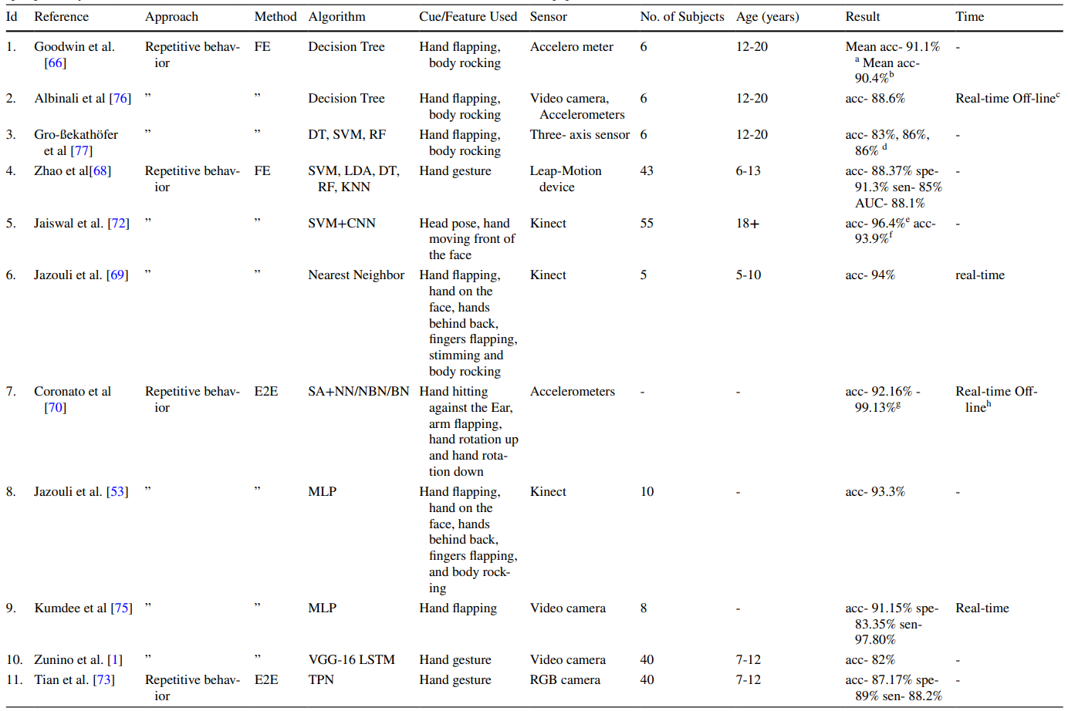

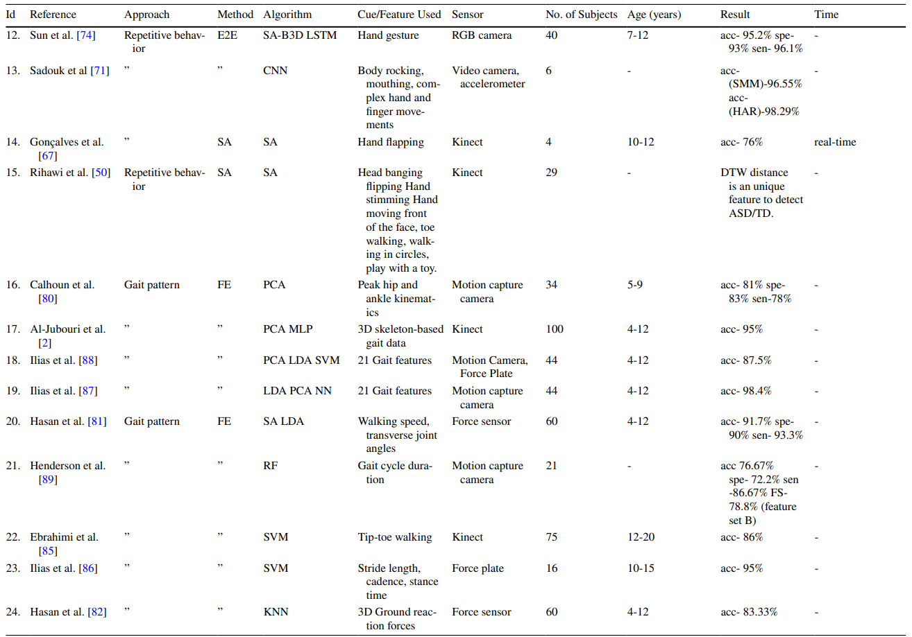

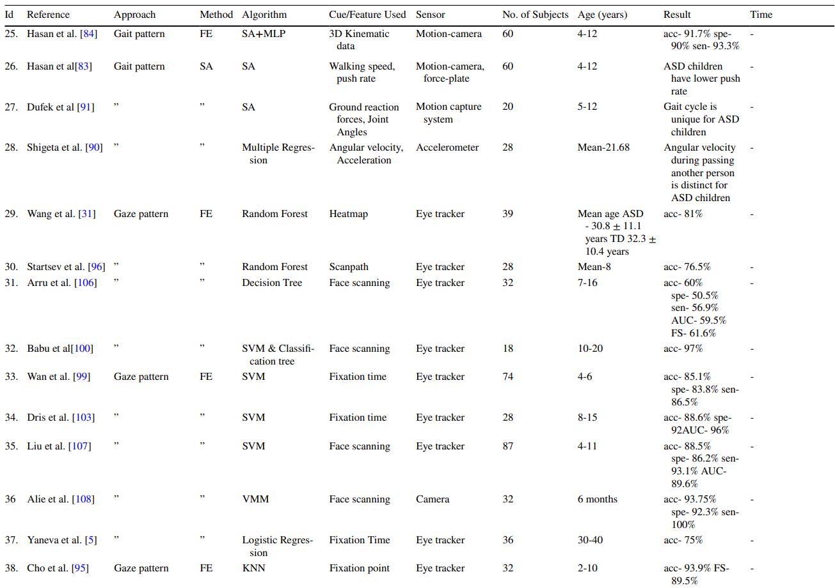

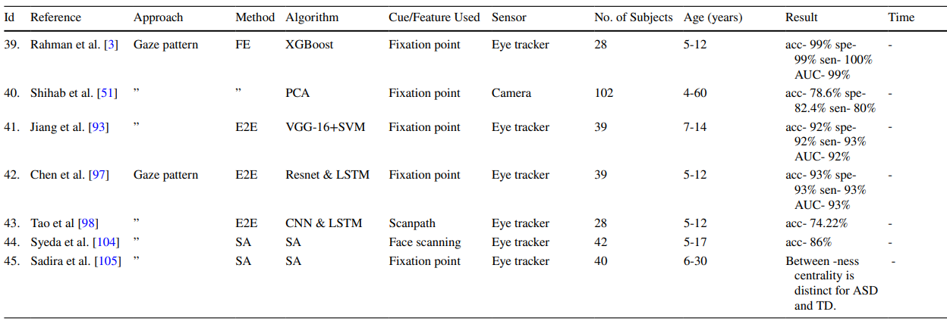

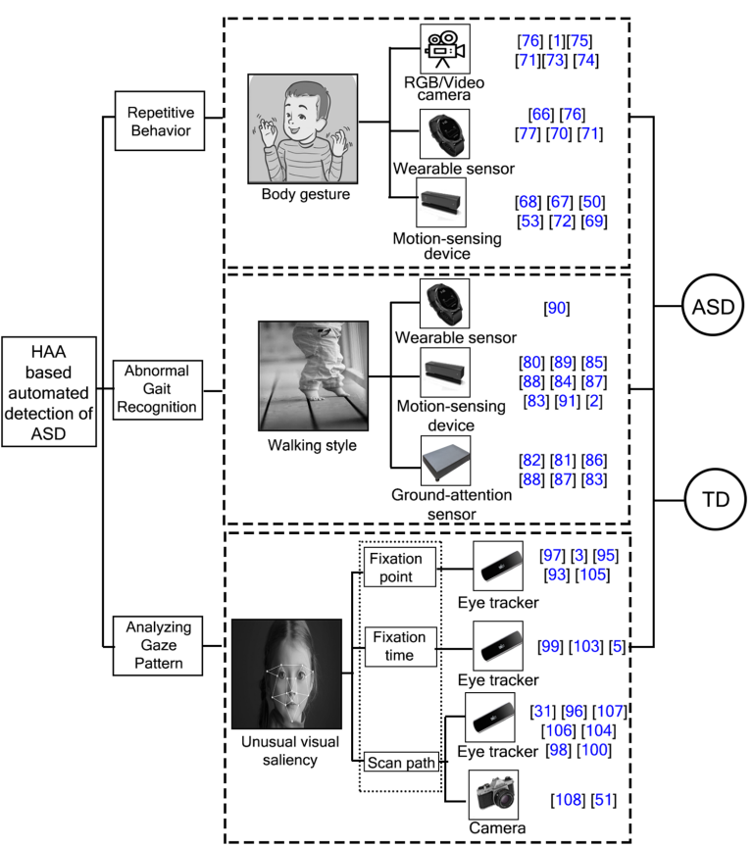

1. **Social Recognition of Joint Attention Cycles in Children With Autism Spectrum Disorders**

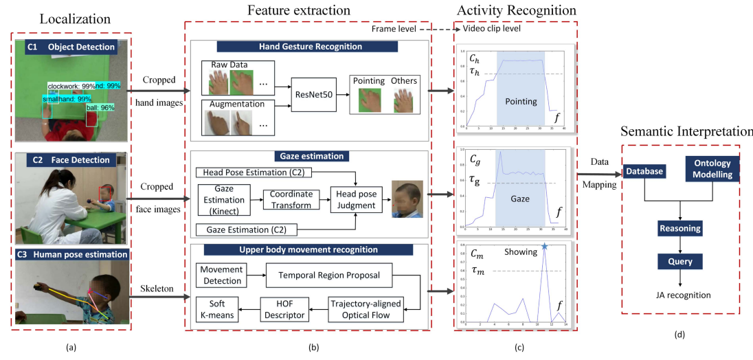

-> automatic recognition of both responding to JA (RJA) and initiating JA (IJA) in children with ASD.

-> multi-modal framework combining vision and human behavior analysis for joint attention assessment.

**Dataset:**

-> The dataset consists of recordings of free play sessions between children (ASD and typically-developing) and adults in a controlled environment.

-> The children were aged 4-6 years old.

-> Ground truth labels for JA cycles were provided by human coders.

-> Included children with ASD, mental retardation (MR), developmental language disorder (DLD), and typically developed children (TD).

-> 7 children with ASD, 5 with MR, 5 with DLD, and 3 TD children.

The framework employs a multi-stage approach:

* Localization: Detects the positions of the child and adult in the video frames.
* Feature Extraction: Extracts features related to gaze direction, head pose, hand gestures, and object interactions.
* Activity Recognition: Utilizes a rule-based approach to identify three key JA activities:
  + Attention estimation (e.g., following gaze direction)
  + Spontaneous pointing
  + Showing actions
* JA Cycle Recognition: Combines the identified activities into temporal sequences to recognize JA cycles.

-> Gaze direction and head pose: estimated from facial landmarks extracted using a pre-trained deep learning model (MTCNN).

-> Hand gestures and object interactions: detected using open-source libraries (OpenPose, YOLOv5).

**Methodology:**

Leverages localization, feature extraction, and activity recognition.

Links critical activities in joint attention (JA) through semantic interpretation.

Performance Metric:

Intra-class coefficient of 0.959.

Demonstrates recognition reliability.

-> Results:

-> Significant differences in JA performance between ASD and TD groups.

-> Significant correlations found between RJA task response latency and IJA times, as well as between social gaze accumulation and JA performance.

-> Limitations Addressed:

-> Small sample sizes acknowledged.

-> Need for improvement in feature extraction methods and statistical analysis highlighted.

-> Potential Applications:

-> Highlighted potential in clinical diagnosis and intervention.

-> Future considerations include increasing sample size, refining technical methods, and conducting further statistical analyses.

-> Contribution:

-> Provides a comprehensive framework for recognizing JA in children with ASD, MR, DLD, and TD.

-> Offers potential for improving clinical diagnosis of autism and enhancing joint attention skills in affected children.